int empnumber=sc.nextInt();

String designationofemployee[];

designationofemployee=new String[7];

int da_sal[];

da_sal=new int[7];

int salary[];

salary=new int[7];

for(int a=0;a<7;a++)

{

if(designationcode[a]=="e")

{

designationofemployee[a]="Engineer";

da_sal[a]=20000;

}

else if(designationcode[a]=="c")

{

designationofemployee[a]="Consultant";

da_sal[a]=32000;

}

else if(designationcode[a]=="k")

{

designationofemployee[a]="Clerk";

da_sal[a]=12000;

}

else if(designationcode[a]=="r")

{

designationofemployee[a]="Receptionist";

da_sal[a]=15000;

}

else if(designationcode[a]=="m")

{

designationofemployee[a]="Manager";

da_sal[a]=40000;

}

}

for(int b=0;b<7;b++)

{

salary[b] = basic[b] + hra[b] + da_sal[b] - it[b];

}

for(int i=0;i<=7;i++)

{

if(i==7)

{

System.*out*.println("there is no employee with empid: "+empnumber);

break;

}

else if(empno[i]==empnumber)

{

System.*out*.print(empno[i]+" "+empname[i]+" "+department[i]+" "+designationofemployee[i]+" "+salary[i]);

break;

}

}

System.*out*.println("\n" + "Ishu Rattan(20BCS7755)");

}

}

**Output:**

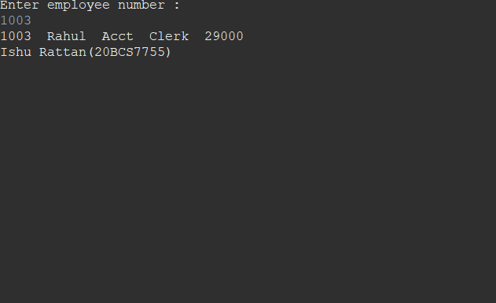

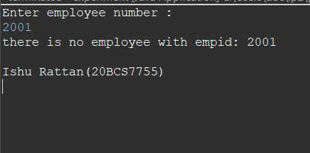

**Learning Outcome:**

1. Learned about using switch case.
2. Learned to take inputs from the user.

**Evaluation Grid (To be created as per the SOP and Assessment guidelines by the faculty):**

|  |  |  |  |
| --- | --- | --- | --- |
| Sr.No. | Parameters | Marks Obtained | Maximum Marks |
|  |  |  |  |
|  |  |  |  |
|  |  |  |  |
|  |  |  |  |